Albury Wodonga Table Tennis Association Inc (AWTTA)

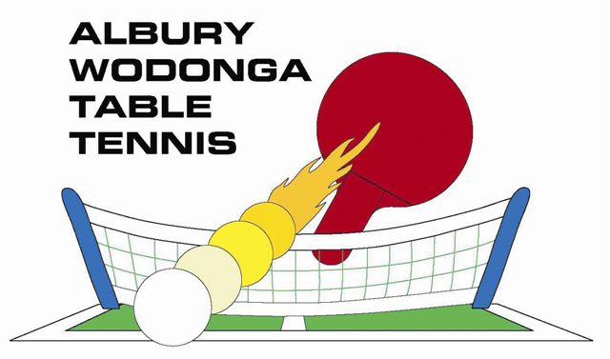

471 North St. Albury (Greenfield Park), Albury. N.S.W. 2640

Contact: Terry Caldwell or John Zinkovsky

Mobile: 0400 533 741 or 0407 241 023

Albury Wodonga Keenagers Event, March 20-21, 2026. Entry Form

**Matches:** All Doubles (best of five for semi-finals and finals; best of three for earlier rounds).

**Divisions**: Submitted Divisions refined/finalised by “Grading” events. Each doubles partnership will play in only one division. Proposed: “Top Table” style of grading as per revised Grading Guidelines document

X=Mixed; M=Male/Men; F=Female/Ladies:

|  |  |  |
| --- | --- | --- |
| Name: |  | |
| Phone: |  | Gender(circle): M F |
| Email: |  | |
| Club: |  | |

**FRIDAY March 20, 2026 (times are only approximates)**

8.15am-1130am: AWTTA Keenagers session (Visitors welcome). **NB: Submitted Division = 1, 2 or 3**

|  |  |  |  |
| --- | --- | --- | --- |
| Time | Event | Partner’s Name & Club | Submitted Div |
| 10.30am | *Morning Tea* |  |  |
| 11.45am | Mixed (X) Grading #1 |  |  |
| 12.15pm | Mixed (X) Grading #2 |  | |
| 1.00pm | *Lunch* |  |  |
| 1.45pm | X Div 1,2&3 (rounds 1&2) | Social play or practice permitted on available tables | |
| 3.15pm | *Afternoon Tea* |  | |
| 3.40pm | X Semi-Finals & Finals | For X3, X2, X1 | |

6.00pm to 9.00pm Dinner, Trophy Presentations, Trivia rounds and chat.

**SATURDAY March 21, 2026 (times are only approximates)**

**NB: Submitted Division = 1, 2 or 3**

|  |  |  |  |  |
| --- | --- | --- | --- | --- |
| Time | Event | Partner’s Name & club | | Submitted Div |
| 9.00am | Ladies (F) Grading |  | |  |
| 9.45am | *Morning Tea* |  | | |
| 10.15am | Mens (M) Grading |  |  | |
| 11.00am | F Div 1,2&3 (rounds 1&2)) | Social play or practice permitted on available tables | | |
| 12.15pm | *Lunch* |  | | |
| 1.00pm | F Semi-Finals & Finals |  | | |
| 2.00pm | M Div 1,2&3 (rounds 1 &2) | Social play or practice permitted on available tables | | |
| 3.15pm | *Afternoon Tea* |  | | |
| 3.40pm | M Semi-Finals & Finals |  | | |

5.45pm Drinks & Nibbles available.

6.00pm to 9.30pm Dinner, Trophy Presentations, Raffle Draw, Trivia rounds and chat.

Players’ cost is **$35 per day**. Includes all play, Lunch, Morning Tea, Afternoon Tea and Dinner each day. Non-players $30 per day or $20 if just dinner.

Payment: Card or Cash on day (perhaps club rep pays for club group).

Entries preferably emailed to [Keenagers@awtta.org.au](mailto:Keenagers@awtta.org.au) (cc [President@awtta.org.au](mailto:President@awtta.org.au) )

If sending by post, please allow sufficient time (please allow at least a week).

Entries preferred by Tuesday March 10, 2026, but late entries accepted on Event days, at least one hour before Grading event for that division.